STRUCTURED UNDERGRADUATE THESIS
MANUSCRIPT FORMAT AND ACADEMIC
WRITING TEMPLATE

Presented to the faculty of
College of Engineering and Architecture
CAGAYAN STATE UNIVERSITY
Carig, Campus
Tuguegarao City, Cagayan

In Partial Fulfillment
of the Requirements for the Degree
BACHELOR OF SCIENCE IN CIVIL ENGINEERING

GIVEN M. LAST NAME
GIVEN M. LAST NAME
GIVEN M. LAST NAME
GIVEN M. LAST NAME

April 2026

APPROVAL SHEET
This thesis titled “STRUCTURED UNDERGRADUATE THESIS MANUSCRIPT FORMAT AND ACADEMIC WRITING TEMPLATE”, prepared and submitted by GIVEN M. LAST NAME, GIVEN M. LAST NAME, GIVEN M. LAST NAME, and GIVEN M. LAST NAME in partial fulfilment of the requirements for the degree, Bachelor of Science in Civil Engineering major in Structural Engineering, is hereby recommended for final defense.

ENGR. GIVEN M. LAST NAME
Adviser

Approved by the Tribunal on Oral Examination with a grade of _______.

ENGR. GIVEN M. LAST NAME
Chairman

ENGR. GIVEN M. LAST NAME ENGR. GIVEN M. LAST NAME
Member Member

ENGR. GIVEN M. LAST NAME
Department Chair

Accepted and approved partial fulfillment of the requirements for the degree, Bachelor of Science in Civil Engineering major in Construction Engineering Management.

April 01, 2026 ENGR. GIVEN M. LAST NAME Date Dean, College

DEDICATION
This section is a personal note where the researcher dedicates the work to individuals or groups who provided inspiration, support, or motivation. It is usually written in a heartfelt and informal tone compared to the rest of the manuscript.

AUTHORS

Researchers

ACKNOWLEDGEMENT
This section expresses gratitude to those who contributed to the completion of the study. It can include advisers, faculty members, classmates, family, friends, and institutions. The tone is formal but appreciative.

TABLE OF CONTENTS
APPROVAL SHEET ii
DEDICATION iii
ACKNOWLEDGEMENT iv
TABLE OF CONTENTS v
LIST OF TABLES vii
LIST OF FIGURES viii
ABSTRACT ix
CHAPTER I 1
THE PROBLEM AND ITS BACKGROUND 1
1.1 Introduction 1
1.2 Statement of the Problem 1
1.3 Objective of the Study 1
1.4 Conceptual or Theoretical Framework of the Study 2
1.5 Significance of the Study 2
1.6 Scope and Delimitation 2
1.7 Definition of Terms 2
CHAPTER II 3
REVIEW OF RELATED LITERATURE 3
2.1. Introduction 3
2.2. Main Topic 3
2.3. International Perspective 3
2.4. National/Local Perspective 4
2.5. Synthesis 4
CHAPTER III 5
METHODOLOGY 5
3.1 General Overview 5
3.1 Study Area (if applicable) 5
3.2 Research Design 6
3.3 Materials, Instruments, or Respondents 7
3.4 Population and Sample 7
3.5 Research Instrument 8
3.6 Data Gathering Procedure 8
3.7 Reliability Test 8
3.8 Statistical Tools 9
3.9 Ethical Consideration 9
CHAPTER IV 10
RESULTS AND DISCUSSION 10
4.1 Introduction 10
4.2 Specific Objective 1 (Replace this heading with the descriptive title of your first objective, i.e., “Profile of the Respondents”) 10
4.3 Specific Objective 2 (Replace this heading with the descriptive title of your next objective, i.e., “Relationship Between Variables”) 10
CHAPTER V 11
CONCLUSION AND RECOMMENDATION 11
5.1 Summary 11
5.2 Conclusion 11
5.3 Recommendations 11
REFERENCES 12
APPENDICES 13
Appendix A. Guide to Appendices 13
Appendix B. Typical Appendix Contents 14

LIST OF TABLES
Table No. Title of Table Page
1 Distribution of Respondents by Sex 19

LIST OF FIGURES
Figure No. Title of Figure Page
1 Map of Cagayan State University Carig Campus 17

ABSTRACT
TITLE : STRUCTURED UNDERGRADUATE THESIS MANUSCRIPT FORMAT AND ACADEMIC WRITING TEMPLATE
RESEARCHER/S : FIRST M. LAST NAME
INSTITUTION : CAGAYAN STATE UNIVERSITY CARIG CAMPUS
DEGREE : BACHELOR OF SCIENCE IN CIVIL ENGINEERING
YEAR : 2026
ADVISER : ENGR. FIRST M. LAST NAME, PhD

The abstract should provide a concise yet comprehensive overview of the study, typically ranging from 150 to 300 words. It begins with a brief introduction that establishes the topic and explains its importance, giving readers immediate context for why the research matters. This is followed by a clear statement of the problem that identifies the central issue and highlights the research gap, pointing out what is lacking, unclear, problematic, or underexplored in existing literature or practice, and explaining how the study intends to address this gap. The abstract should then state the objectives of the study in one or two sentences, ensuring they are specific, measurable, and directly connected to the problem identified. After this, the methods are summarized by briefly describing the research design, participants, instruments, and procedures, with enough detail to show how the study was conducted but without unnecessary elaboration. The results are then presented in a straightforward sentence or two, emphasizing the most significant findings that directly relate to the objectives and provide evidence to answer the research questions. Finally, the abstract concludes with a sentence that ties the results back to the problem and research gap, showing how the study contributes new knowledge, insights, or practical applications, and indicating its broader implications. After the abstract, a list of 3 to 6 keywords should be added, arranged alphabetically or by relevance, to capture the main themes of the study and aid in indexing for future reference. If this template is not showing/downloaded properly, you may access the template at https://tinyurl.com/COEAManuscriptTemplate2.

Keywords: most; relevant; words

CHAPTER I

THE PROBLEM AND ITS BACKGROUND

1.1 Introduction
This section provides the context of the study. Briefly introduce the topic, explain why it is important, and outline the general area of concern. It should set the stage for the problem statement by giving background information and highlighting gaps or issues in existing knowledge.

1.2 Statement of the Problem
Summarize the central issue that the study seeks to address. Highlight the research gap by identifying what is lacking, unclear, problematic, or underexplored in existing literature or practice. Explain how your study intends to fill this gap and present the problem in a way that demonstrates the necessity and relevance of conducting the research.

1.3 Objective of the Study
State the overall aim of the research. Then list specific objectives in numbered form. These objectives should be measurable and directly tied to solving or clarifying the problem identified. For example:
- To determine…
- To analyze…
- To compare…

1.4 Conceptual or Theoretical Framework of the Study
Explain the theory or model that supports the research. Use diagrams or flowcharts if needed to show relationships among variables. This section should demonstrate how the study is grounded in established concepts and how it contributes to or extends them.

1.5 Significance of the Study
Discuss who will benefit from the research and in what ways. Mention contributions to students, educators, policymakers, practitioners, or future researchers. Keep it concise but clear about the practical and academic value of the study.

1.6 Scope and Delimitation
Define the boundaries of the study. Explain what is included (scope) and what is intentionally excluded (delimitation). This helps readers understand the limits of the research and prevents misinterpretation of its coverage.

1.7 Definition of Terms
Arrange key terms used in the study alphabetically for easy reference and provide clear definitions of each key term.
Definitions should be specific to how the terms are applied in your research context, not just dictionary meanings.

CHAPTER II

REVIEW OF RELATED LITERATURE
This chapter presents foreign and local literature, as well as related studies that provide context and support for the research.

2.1. Introduction
This section introduces the purpose of the Review of Related Literature. It explains that the chapter surveys existing works relevant to the study, including both international and local perspectives. While the subsections provided in this format (Main Topic, International Perspective, National/Local Perspective, and Synthesis) offer a clear structure, researchers are not required to follow this sequence strictly. They may organize the literature in a way that best presents their topic, whether by themes, chronology, variables, or perspectives, as long as the chapter concludes with a synthesis that integrates the reviewed works and connects them to the present study.

2.2. Main Topic
Discuss the central theme or subject of your study. Present relevant theories, concepts, or prior works that directly relate to your research focus. This section should establish the foundation for the perspectives that follow.

2.3. International Perspective
Summarize studies, articles, and literature from foreign or international sources. Highlight how global research has approached the topic, noting similarities, differences, or gaps that may be relevant to your study.

2.4. National/Local Perspective
Present literature and studies conducted within the country or local context. Emphasize findings that are specific to your region, community, or national setting, and explain how they connect to or differ from international perspectives

2.5. Synthesis
Conclude the chapter by integrating insights from both international and local literature. Point out common themes, contradictions, and gaps. Show how the reviewed works collectively justify the need for your study and how they lead toward your research objectives. The synthesis should clearly demonstrate the contribution your study intends to make.

CHAPTER III

METHODOLOGY
This chapter explains the methods and procedures used in the study. It must be documented clearly enough that another researcher could replicate the work. While the subsections below provide a suggested framework, students should adapt the methodology to their research type. Experimental, simulation, modeling, and design studies may require different emphases, and the order of subsections may vary. What matters is that the methodology is systematic, transparent, and replicable, with statistical tools and ethical considerations always included at the end.

3.1 General Overview
Provide a brief outline of the methodology. State the type of research (survey, experimental, simulation, modeling, design, qualitative, mixed methods, etc.) and explain why this approach is appropriate. This section sets the stage for the subsections that follow.

3.1 Study Area (if applicable)
For survey-type studies, describe the geographic or institutional setting where the survey was conducted. Include maps or contextual details if relevant. For experimental or simulation studies, this section may be omitted or replaced with a description of laboratory facilities or computational environments.
Figure 1 shows the map of Cagayan State University Carig Campus. All figures should be formatted with in-line wrapping, single spacing, and a caption placed directly below the figure as a stand-alone description.
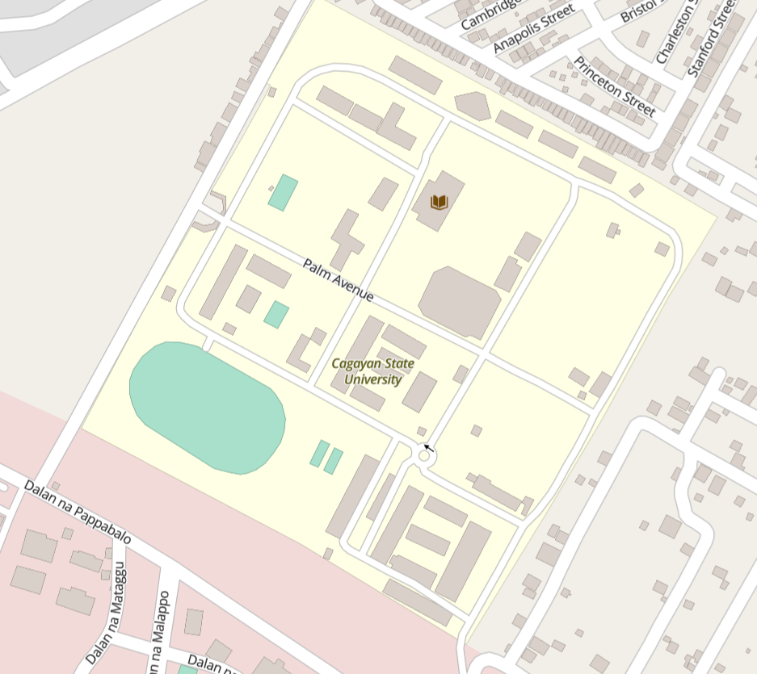
Figure 1. Map of Cagayan State University Carig Campus

3.2 Research Design
Explain the overall design of the study and justify why this design is appropriate. The methodology should highlight the specific aspects that are central to the chosen design. For survey-type studies, focus on the formulation of questions, respondent selection, and procedures for data collection. For experimental studies, emphasize materials selection, procurement, processing, design of experiments, and characterization techniques. For simulation studies, detail the algorithms, models, assumptions, and validation procedures. For modeling studies, concentrate on mathematical formulations, predictive structures, and verification steps. For qualitative studies, describe case selection, interview protocols, or thematic analysis procedures. For mixed-methods studies, explain how quantitative and qualitative approaches are integrated and how data from both are triangulated.

3.3 Materials, Instruments, or Respondents
This section should provide a clear description of the specific elements directly involved in the conduct of the study. The focus will vary depending on the research type, but the discussion must go beyond simple listing and instead explain how these elements contribute to achieving the objectives. For studies that involve physical experimentation, the methodology should detail the materials used, the instruments or equipment employed, and any relevant preparation or handling procedures. For studies that rely on computational or simulation approaches, the emphasis should be on the software platforms, datasets, or models applied, including any parameters or configurations that are critical to the analysis. For survey-based studies, this section should describe the respondents, their demographic or institutional characteristics, and the rationale for their inclusion.

3.4 Population and Sample
For survey-based studies, define the population and explain how the sample was selected. In other contexts, this may refer to the number of test specimens, trials, or simulation runs.
Table 1 presents the distribution of respondents by sex. Tables should be formatted with single spacing, captions placed above the table and presented as stand-alone descriptions.
Table 1. Distribution of Respondents by Sex*
SEX | RESPONDENTS | PERCENTAGE
Male | 12 | 40%
Female | 18 | 60%
Total | 30 | 100%
* Supporting notes can be included here.

3.5 Research Instrument
Describe the instruments used to collect data. For surveys, this may include questionnaires. For experiments, laboratory equipment. For simulations, software tools.

3.6 Data Gathering Procedure
Explain step by step how data were collected. For survey research, describe distribution and retrieval of questionnaires. For experimental research, detail preparation of materials, testing protocols, and measurement techniques. For simulation or modeling, describe input parameters, computational steps, and validation.

3.7 Reliability Test
Discuss how reliability of instruments or methods was tested. This may include calibration of equipment, repeatability of experiments, or consistency checks in surveys and simulations.

3.8 Statistical Tools
List and briefly explain the statistical tools used for data analysis. Common tools such as mean, standard deviation, t-tests, or ANOVA, need not have their formulas shown, since they are already well established. Equations should only be presented if they are central to the study, such as in modeling or specialized analysis.
Equation 1 illustrates the area of a circle, included here as an example of how equations should be formatted. Equations must be centered, numbered on the right, and followed by definitions of variables.
$$A=πr^{2}$$ | (1)

where $A$ is the area of the circle, $r$ is the radius of the circle and π is a constant, approximately 3.1416.

3.9 Ethical Consideration
State how ethical standards were observed, such as informed consent for surveys, confidentiality of data, safe handling of materials, and proper citation of sources.

CHAPTER IV

RESULTS AND DISCUSSION
This chapter presents the findings of the study and interprets them in relation to the objectives and literature reviewed. Results should be organized according to the research objectives, with each subsection presenting the findings and immediately discussing their meaning.

4.1 Introduction
Provide a brief overview of the chapter. State that results will be presented per objective and discussed considering related literature.

4.2 Specific Objective 1 (Replace this heading with the descriptive title of your first objective, i.e., “Profile of the Respondents”)
Present the results related to the first objective. Use tables, figures, or graphs where appropriate. Each table, figure, or equation must be referenced in the text, formatted consistently, and accompanied by a clear caption. Immediately follow with discussion that connects the findings to existing studies or theories

4.3 Specific Objective 2 (Replace this heading with the descriptive title of your next objective, i.e., “Relationship Between Variables”)
Present the results related to the second objective. Again, reference any supporting visuals or equations in the text, and provide interpretations that link the findings to the research problem and reviewed literature. Repeat subsections for additional objectives as needed, always pairing results with discussion.

CHAPTER V

CONCLUSION AND RECOMMENDATION
This chapter summarizes the study, presents conclusions based on the findings, and offers recommendations for practice, policy, or future research.

5.1 Summary
Provide a concise recap of the study’s purpose, methodology, and major findings. This should be written in paragraph form, not as bullet points.

5.2 Conclusion
State the conclusions drawn directly from the results. Each conclusion should clearly answer the research objectives. Avoid introducing new data here.

5.3 Recommendations
Offer practical or theoretical recommendations based on the conclusions. These may include suggestions for institutions, practitioners, policymakers, or future researchers. Recommendations should be specific, actionable, and logically derived from the findings.

REFERENCES
All sources cited in the manuscript must be listed in the References section, formatted according to APA style (7th edition). In-text citations should follow the author–date format, while the reference list must be arranged alphabetically by the first author’s surname, single-spaced, and formatted with a hanging indent. Journal titles are italicized, volume numbers included, and DOI links provided when available. Hypothetical examples are as follows (for template purposes only):
Dela Rosa, A. (2025, March 15). Local universities expand sustainability initiatives. The Philippine Daily Chronicle. https://www.philchronicle.ph/news/sustainability-initiatives
GreenFuture Organization. (2025). Climate action projects in Southeast Asia. Retrieved February 10, 2026, from https://www.greenfuture.org/projects
Lopez, F. G. (2021). Assessing water management practices in rural communities (Unpublished undergraduate thesis). Cagayan State University, Carig Campus.
Ramirez, J. P. (2022). Foundations of research methodology: A practical guide (2nd ed.). Manila Academic Press.
Santos, R. L., & Cruz, M. T. (2024). Renewable energy adoption in urban communities: A comparative study. Journal of Sustainable Development Studies, 18(2), 45–62. https://doi.org/10.1234/jsds.2024.5678
Villanueva, K. M. (2023). Smart building technologies for tropical climates. In Proceedings of the International Conference on Sustainable Engineering (pp. 112–120). Singapore Institute of Technology.

APPENDICES

Appendix A. Guide to Appendices
The appendices provide supplementary material that supports the study but is too detailed or lengthy to include in the main text. Each appendix should be labeled clearly, using the format “Appendix A. Title/Description” or “Appendix B. Title/Description”, with the content following immediately after the label and title. Appendices must be referenced in the body of the manuscript where relevant, and they should contain materials such as survey instruments, raw data tables, sample calculations, extended descriptions of procedures, or supplementary figures and diagrams.
Figures, tables, and equations included in the appendices must have numbering that is separate from the main text. To distinguish them, use the appendix letter as a prefix. For example, figures in Appendix A should be labeled as Figure A1, Figure A2, and so on, while tables should be labeled as Table A1, Table A2, and equations as (A1), (A2). In Appendix B, numbering would continue as Figure B1, Table B1, and (B1), respectively.

Appendix B. Typical Appendix Contents
Typical contents for the appendices may include:
- Copies of survey questionnaires or interview guides
- Raw data tables or extended datasets
- Sample calculations or derivations
- Detailed descriptions of instruments or procedures
- Additional figures, charts, or diagrams not central to the main discussion
Appendices should be formatted consistently, with clear titles and stand-alone descriptions. They serve as supporting evidence and documentation, ensuring transparency and replicability without interrupting the flow of the main chapters.

